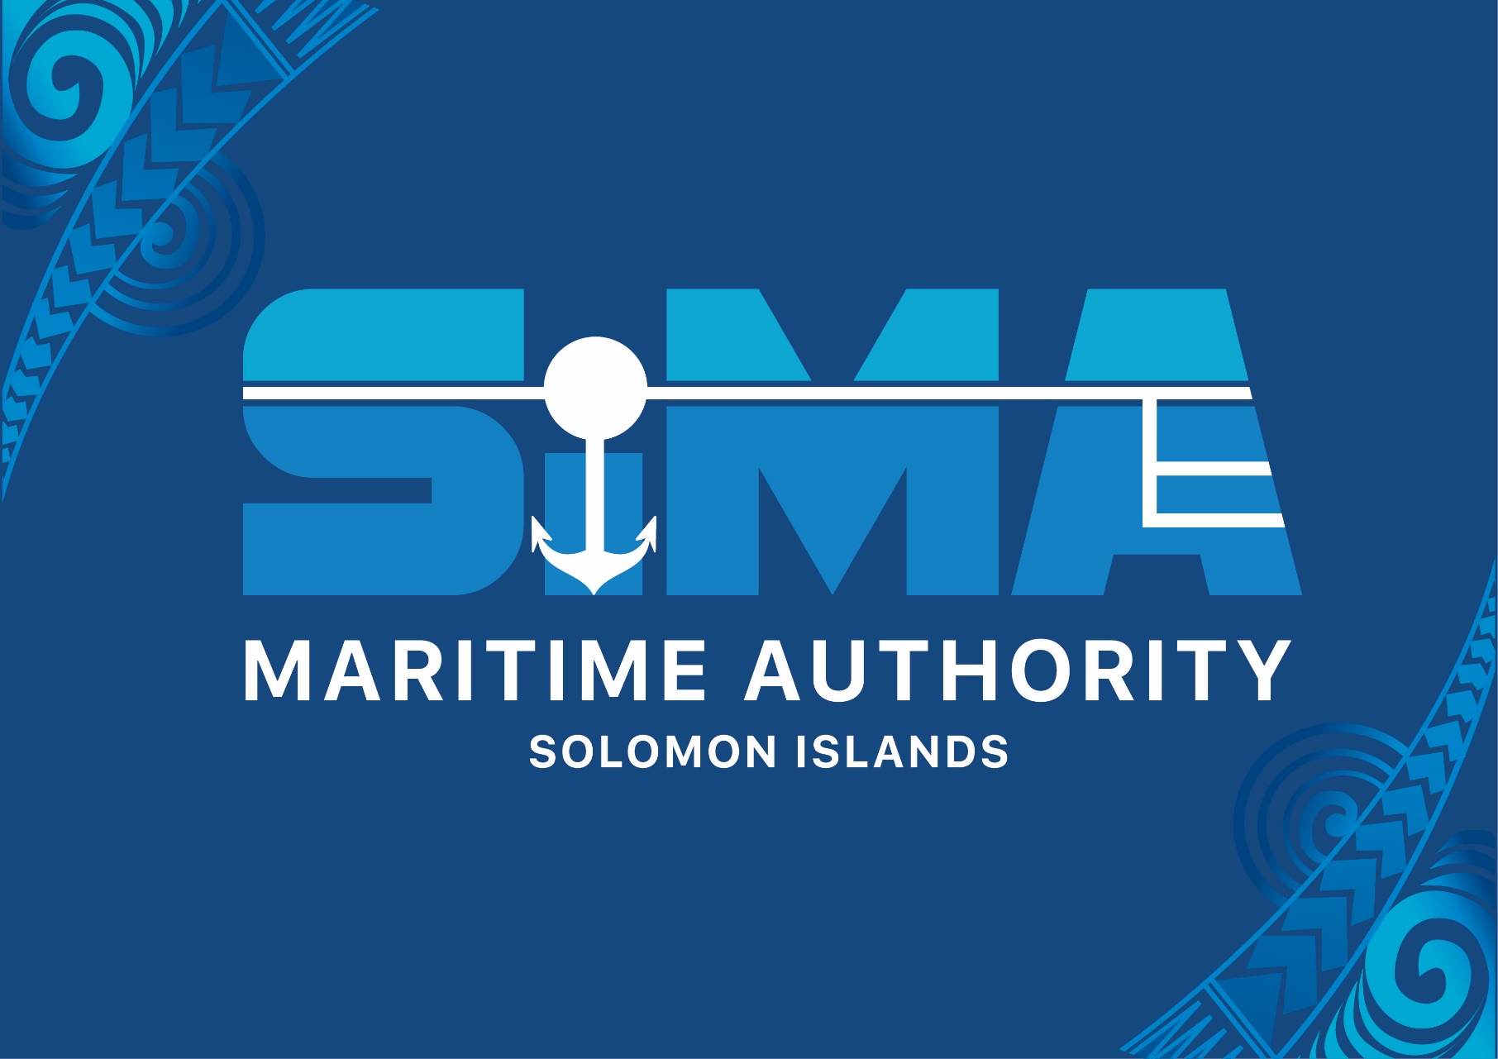

SIMA Executive Office Retreat Program
"Integrity in Action: Cultivating Excellence through Purpose, Accountability & Commitment"
*Friday, 20th June 2025 - Roderick Bay, Central Islands Province*

Introduction
This retreat is designed to help our team reconnect with SIMA's mission and strengthen how we work together. Through simple activities and honest conversations, we will:
Remember why our work matters
Practice making good decisions
Clarify everyone's roles
Find ways to improve our services
Promise to uphold our values
Each session builds toward creating a stronger, more united team. Let's work together to make SIMA the best it can be!

Session 1: Purpose at Work Reconnecting with Our Mission
Activity: Reflection, Sharing, and Mission Map
What We’ll Do:

Think Alone (5 mins): Answer:

Why did I join SIMA?

When did I feel proud of our mission?

What part of our mission is most important to me?

Share in Groups (30 mins): Tell a story about how your work helps SIMA’s mission.

Make a Mission Map (15 mins): Draw how your job connects to SIMA’s goals.

Why It Matters:

Helps everyone see how their work makes a difference.

Brings the team closer by sharing stories.

Session 2: Ethical Decision-Making in the Real World
Activity: Group Discussion and Online Poll
What We’ll Do:

Online Poll (Quick): Answer 3 questions about ethics.

Group Work (40 mins): Talk about a tough ethical problem:

What’s the right thing to do?

What could go wrong?

How would you explain your decision to others?

Share Your Ideas: Present your group’s solution.

Why It Matters:

Teaches how to handle tough choices at work.

Makes teamwork stronger by solving problems together.

Session 3: Accountability Not Just a Checklist
Activity: Role Clarity Game
What We’ll Do:

Write on Sticky Notes (15 mins):

List your top 3 tasks.

Guess your teammates’ top 3 tasks.

Compare and Talk (35 mins):

Find out where people’s jobs are unclear.

Plan how to fix it (e.g., update job descriptions, meet every 3 months).

Why It Matters:

Stops confusion about who does what.

Makes sure everyone knows their responsibilities.

Session 4: Excellence in Service Walking the Talk
Activity: Service Improvement Plan
What We’ll Do:

Rate Your Team (15 mins): Score (1-5) how well you do key tasks.

Group Talk (30 mins): Discuss:

What are we doing well?

What needs to get better?

What small changes can we make?

Why It Matters:

Finds ways to improve your work.

Helps the team agree on simple fixes.

Session 5: Closing Our Integrity Promise
Activity: Pledge and Team Agreement
What We’ll Do:

Look Back: Talk about what we learned (e.g., honesty, teamwork).

Make a Promise: Agree to work with trust, professionalism, and excellence.

Why It Matters:

Ends the retreat on a positive note.

Unites the team around shared goals.

Key Takeaways:
Know Your Purpose (Sessions 1 & 5).

Do the Right Thing (Session 2).

Clear Roles = Strong Team (Session 3).

Always Improve (Session 4).

Result: A team that works better together, with clear goals and trust.

